201635833 Lee SungMin

**Total codes :**

import pandas as pd  
import numpy as np  
  
data = np.array([[3.0,'?',2.0,5.0],  
 ['*',4.0,5.0,6.0],  
 ['+',3.0,2.0,'&'],  
 [5.0,'?',7.0,'!']])  
  
missing_values = ["?","*","+","&","!"]  
  
df = pd.DataFrame(data)  
  
print('df : \n',df)  
  
for i in missing_values:  
 df = df.replace({i:np.nan})  
print('-'*40)  
  
print(df)  
print('-'*40)  
  
print('isna().any() : \n',df.isna().any())  
print('-'*40)  
  
print('isan().sum() : \n',df.isna().sum())  
print('-'*40)  
for i in range(0,2):  
 print('dropna()','axis : ',i,' how = any :\n',df.dropna(axis=i,how='any'))  
print('-'*40)  
  
for i in range(0,2):  
 print('dropna()','axis : ',i,' how = all :\n',df.dropna(axis=i,how='all'))  
print('-'*40)  
  
for i in range(0,2):  
 for j in range(1,3):  
 print('dropna()','axis : ',i,' thresh',j,':\n',df.dropna(axis=i,thresh = j))  
 print('-' * 40)  
  
temp = df  
df= df.fillna(100)  
print('fillna() with 100:\n',df)  
  
print('-'*40)  
df = temp  
print('mean : ',df.mean())  
print('fillna() with mean :\n',df.fillna(df.mean()))  
print('-'*40)  
df = temp  
df = df.fillna(df.median())  
print('fillna with median :\n',df)  
print('-'*40)  
df = temp  
for i in range(0 , 2):  
 print('fillna() with ffill axis=',i,':\n',df.fillna(axis=i,method='ffill'))  
 print("-"*40)  
for i in range(0,2):  
 print('fillna() with bfill axis=', i, ':\n', df.fillna(axis=i, method='bfill'))  
 print("-" * 40)

**Output :**

**Original DataFrame :**

**Change non numberic value with NaN**

**Isna() :**

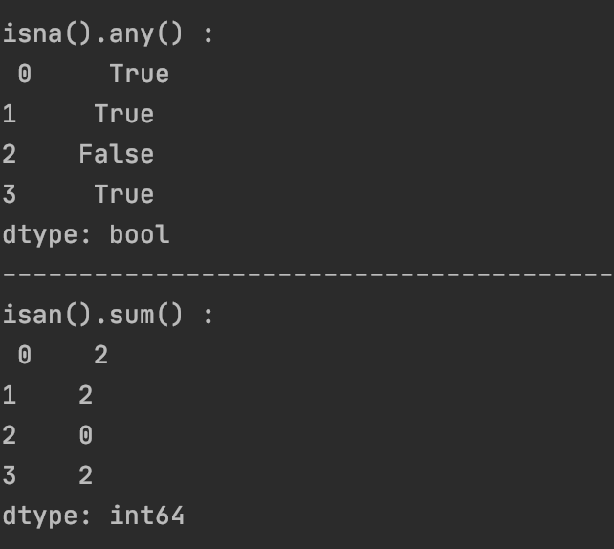

**Dropna() :**

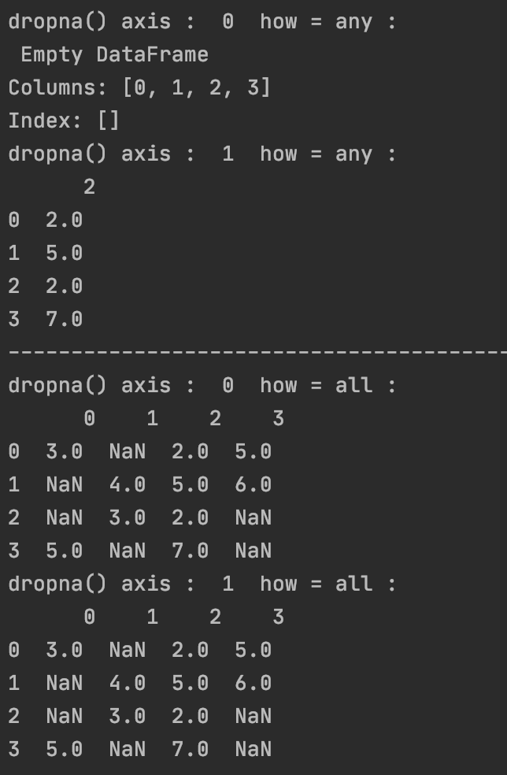

**Dropna() thresh :**

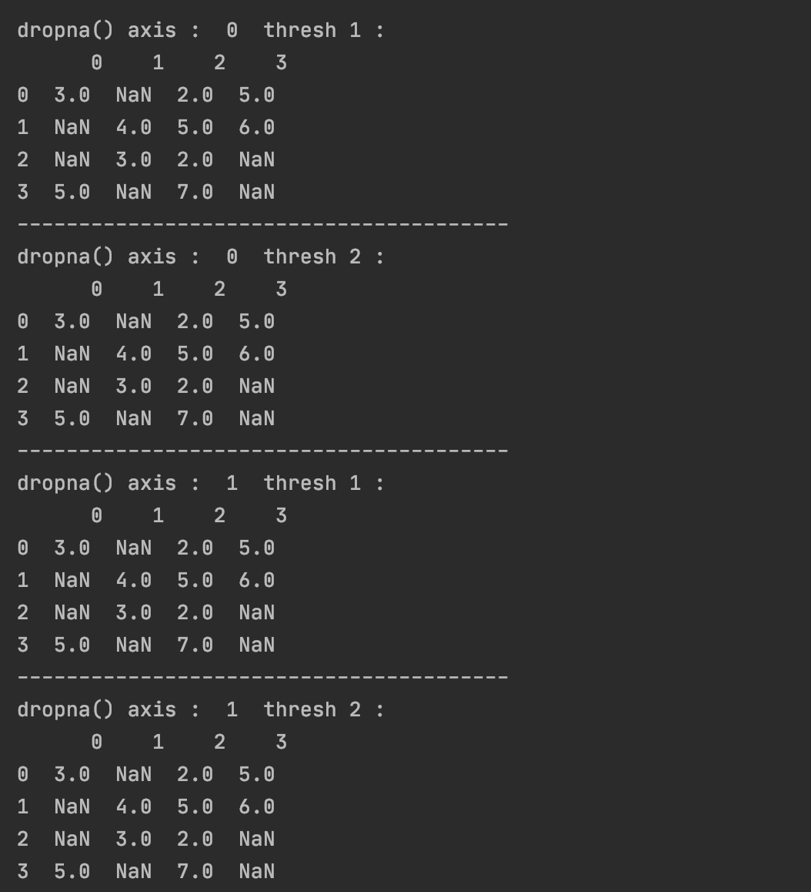

**Fillna() :**

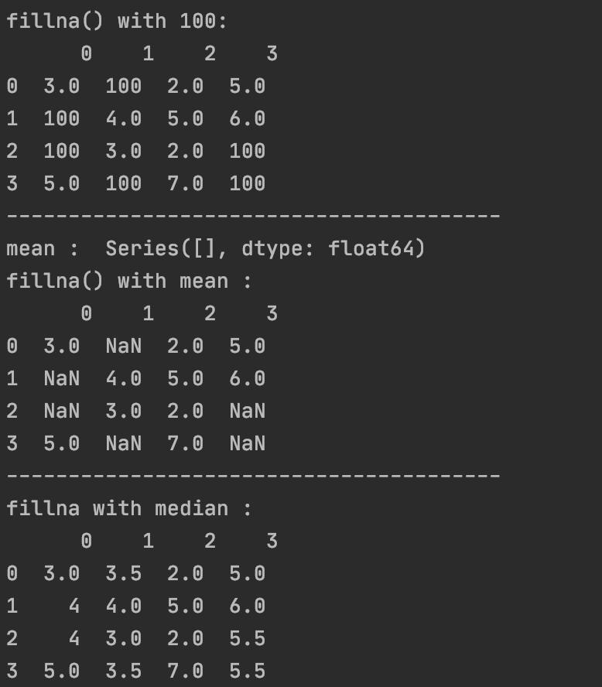

**Fillna() ffill :**

**Fillna() bfil :**

